Unit 3
MICROBIOLOGY
- Study of micro-organisms or microbes.
- Microbes are the organisms which cannot be visualized by naked eyes.
- We need microscope to visualize them.
- Father of ancient microbiology- Anton Van Leeuwenhoek
- Father of modern microbiology- Louis Pasteur
- Pasteur proposed technique of Pasteurization and producers formulated anti rabies vaccine.
Microbial groups include bacteria, viruses, fungi, actinomycetes, algae, protozoa, nematodes, helminthes etc. KINGDOM MONERA:

- Monera first proposed as phylum by Ernst Haeckel in 1866.
- R. H. Whittaker in 1969 established monera as a separate kingdom in his 5 kingdom classification.
- Monerans are cosmopolitan/ omnipresent in distribution that means found everywhere.
- They are microscopic, unicellular and prokaryotic in nature.
- Autotrophic or heterotrophic mode of nutrition.
- Heterotrophic organisms may be parasitic, saprophytic or symbiotic.
- They may be parasitic or decomposers.
- Cell wall may or may not present.
- Reproduction by amitosis cell division.
- Sexual reproduction is generally absent.
- Distinct nucleus, membrane bound cell organelles are absent.
- 70 S type of ribosome is present.
- DNA is naked ( without histone protein).
- Example- Bacteria, Cyanobacteria, Mycoplasma etc.
- Classification of monera:

MONERA

Eubacteria Archaebacteria

Bacteria Cyanobacteria (BGA)

BACTERIA
- A. V. Leeuwenhoek first seen bacteria in rain water under his self made microscope in 1675 and named animalcule.
- In 1838, Ehrenberg named these animalcule as “bacteria”.
- Habit and habitat:
- Bacteria are cosmopolitan in distribution.
- They are found in soil, air water and even inside other organisms.
- General characters:
- They can also live in extreme conditions as in very high or low temperature.
- Unicellular and prokaryotic.
- Incipient nucleus is present (primitive nucleus that means nucleus without nuclear membrane is present).
- Membrane bound cell organelles are absent.
- 70 S type of ribosome is found.
- DNA is naked.
- Bacteria are commonly called as decomposers or mineralizers of ecosystem.
- They are autotrophic or heterotrophic.
- Heterotrophic bacteria may be parasitic, saprophytic or symbiotic.
- Sexual reproduction is generally absent.
- Amitosis cell division takes place.
- Bacteria may be motile or non-motile. Motile forms have flagella.
- Cell wall is made up of murein/ mucopeptide/ peptidoglycan.
- Storage food material is glycogen.
- Shape and size:
- Bacteria varies from 0.2-1.5µm in diameter and 2-10µm in length.
- Smallest bacteria- Dialister pneumosintes
- Largest bacteria- Beggiatoa mirabilis
- Shape of bacteria may be spherical, rod shaped, spiral, comma shaped or pleuromorphic.
- Coccus: Spherical or rounded bacteria are called coccus.

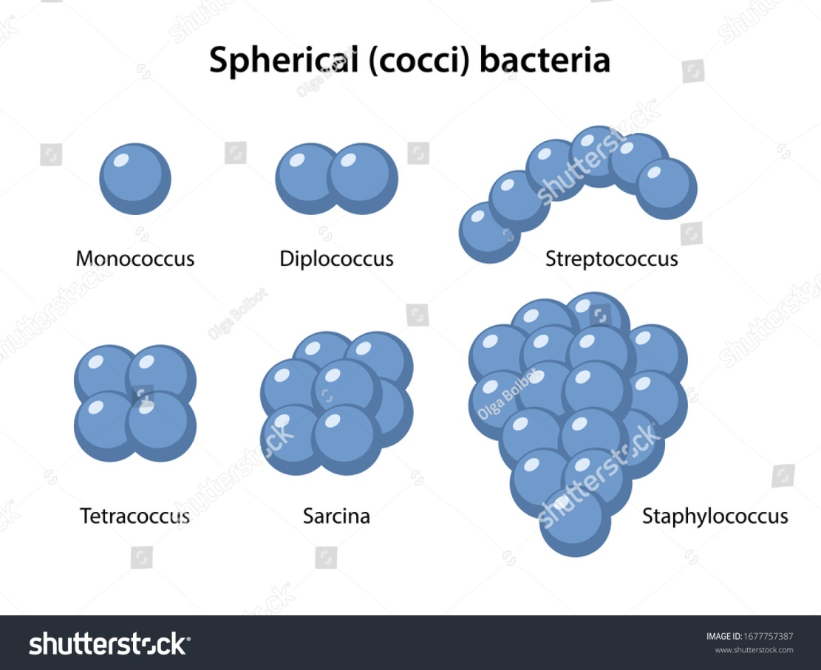

- Bacillus: Rod shaped or cylindrical bacteria are called bacillus. Different forms of bacillus are:
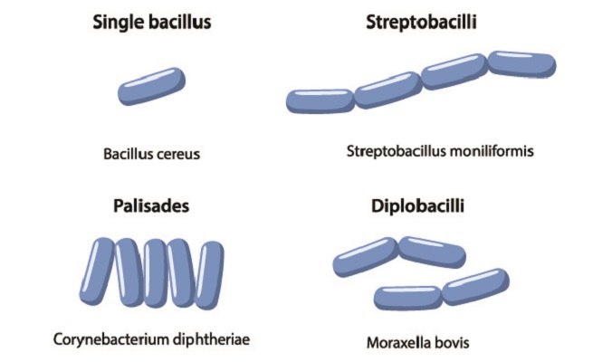
- Vibrio: comma shaped bacteria are called vibrio. Example- Vibrio cholera.

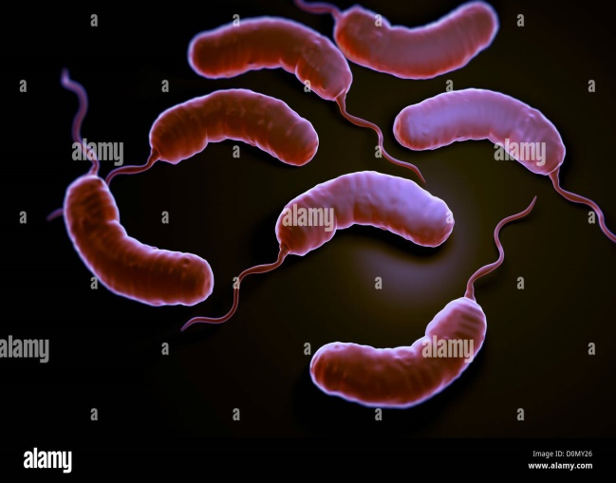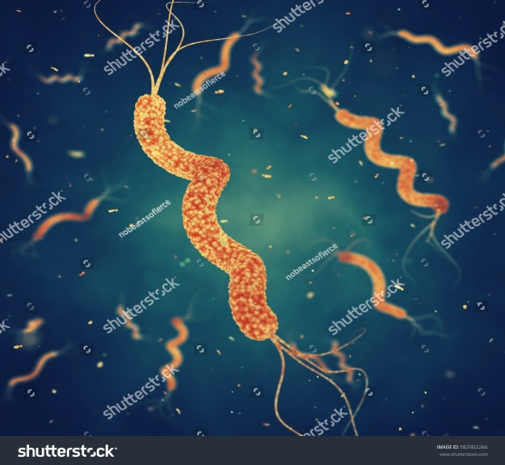
- Spirilla: Curved or twisted bacteria which forms helical/ spiral structure. Example- Spirillum minus.
- Pleuromorphic bacteria: some bacteria exist in many morphological forms and their shape are not fixed.
Example- Rhizobium, Azotobacter etc.

STRUCTURE OF BACTERIAL CELL
- Bacterial cell shows following structures:
- Surface appendages
- Slime layer/ capsule
- Cell wall
- Plasma membrane
- Cytoplasm
- Nuclear material
- Plasmid

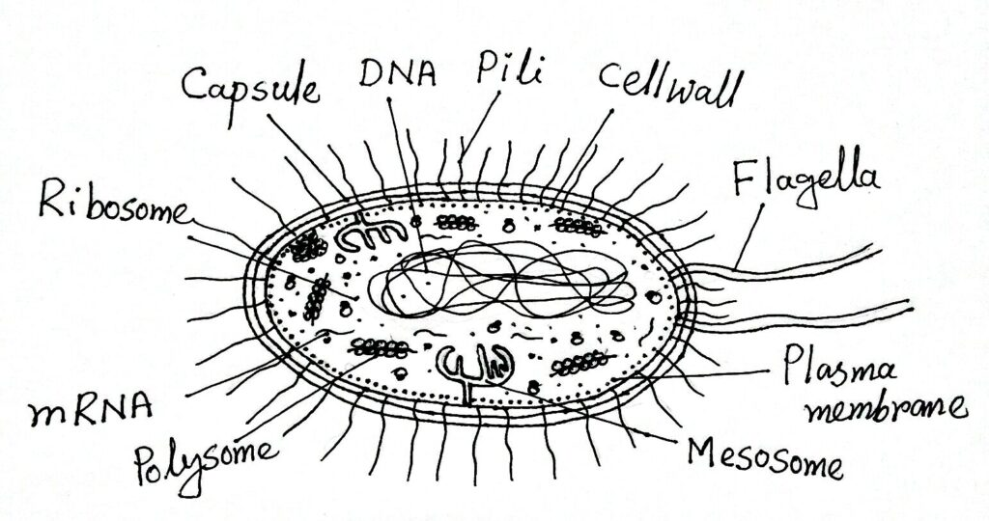
- Surface appendages: In bacteria two types of appendages are found- flagella and pilli.
- Flagella:
- Flagella is long, thin, whip like filamentous structure produced from cell wall of bacteria.
- It helps in locomotion.
- Flagella consists of three parts- basal body, hook and filament.
- Flagella is mainly composed of protein flagellin.
- Depending on the presence or absence of flagella, bacteria are of following types-
- Atrichous: without flagella. e.g. Gram –ve bacteria.
- Monotrichous: single flagella at one end.
- Amphitrichous: single flagella at both the ends.
- Cephalotrichous: many flagella or group of flagella at one end.
- Lophotrichous: bunch of flagella at both the ends.
- Peritricous: flagella is present all around the body surface.
- Pilli:
- Pilli are short, thin, hair like structure found all over the body of bacteria.
- They are also called fimbrae.
- It is made up of protein “pillin”.
- Some pilli help in attachment of bacteria to the host cell during infection.
- Some pilli also help in conjugation. The pilli which help in conjugation are called sex-pilli.
- Slime layer/ capsule:
- It is the outermost, gelatinous coating which is present outside cell wall.
- It protects bacterial cell from dessication and harmful agents.
- This layer is made up of polysaccharides and polypeptides.
- The slime layer is present in all the bacteria.
- In Gram –ve bacteria, this layer also have some amino acids which make it hard and form a capsule. So, Gram –ve bacteria are capsulated one.
- Due to presence of capsule Gram –ve bacteria are more virulent because these bacteria are not affected by chemicals.
- Cell wall:
- It is present just below the slime layer.
- Cell wall is present in all bacteria except Mycoplasma (PPLO= Pleuro Pneumonia Like Organism).
- It is a multilayered structure made up of murein and peptidoglycan.
- Two main sugar backbone present in cell wall are NAM and NAG.
- NAM= N-acyl muramic acid = murein
- NAG= N-acyl glucosamine = peptidoglycan.
- Cell wall is also composed of Teichoic acid.
- Cell wall provides additional protection to bacterial cell against mechanical injury.
- Plasma membrane:
- It is present just below the cell wall and it is a thin, elastic and semi-permeable membrane.
- It is made up of lipoprotein.
- It contains large number of respiratory enzymes. So, it helps in respiration.
- Infoldings of cell membrane are called as mesosome, which are similar to mitochondria in function.
- Plasma membrane also helps to maintain osmotic regulation.
- Cytoplasm:
- A granular cytoplasm is present in between cell membrane.
- It is a colorless viscous substance found between nuclear body and cell membrane.
- It contains soluble proteins, lipids, carbohydrates, enzymes, vitamins and wide range of chemicals.
- Double membranous cell organelles are absent.
- 70 S ribosomes are present.
- Small gas vacuoles are present.
- Photosynthetic lamellae are present in photosynthetic bacteria.
- Storage food material in bacteria are polyhydroxy butyric acid and glycogen.
- Volutin granules are also present.
- Nuclear body:
- Bacteria contain incipient nucleus or nuclear body or nucleoid.
- It contains a naked double stranded, circular DNA molecule.
- It contains genetic information and transfer it during sexual reproduction.
- DNA are self replicating.

- Plasmid:
- In addition to main circular DNA, some bacterial cells have an extra DNA called plasmids.
- It can replicate separately from main DNA.
- These are used as vector in DNA –recombinant technology.
- These are helpful in conjugation.

Gram +ve and Gram –ve bacteria:
- Bacteria are divided into two groups on the basis of their ability to retain or loose Gram’s stain.
- Those which are able to retain Gram’s stain are called Gram +ve and those which lose the stain are called Gram –ve.
- Christain Gram in 1884 developed a staining method for bacteria.
- It needs crystal violet and Gram’s iodine.

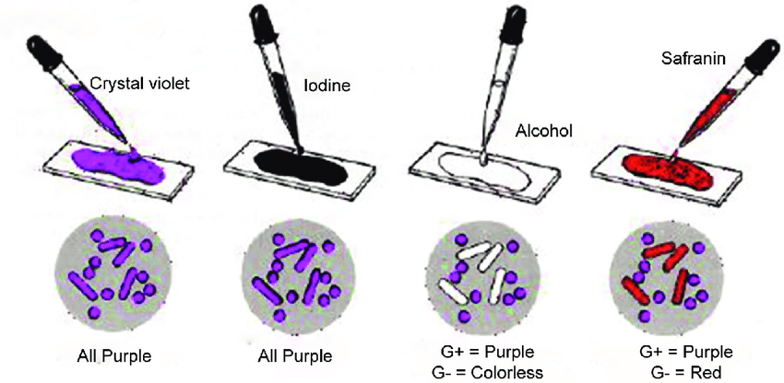
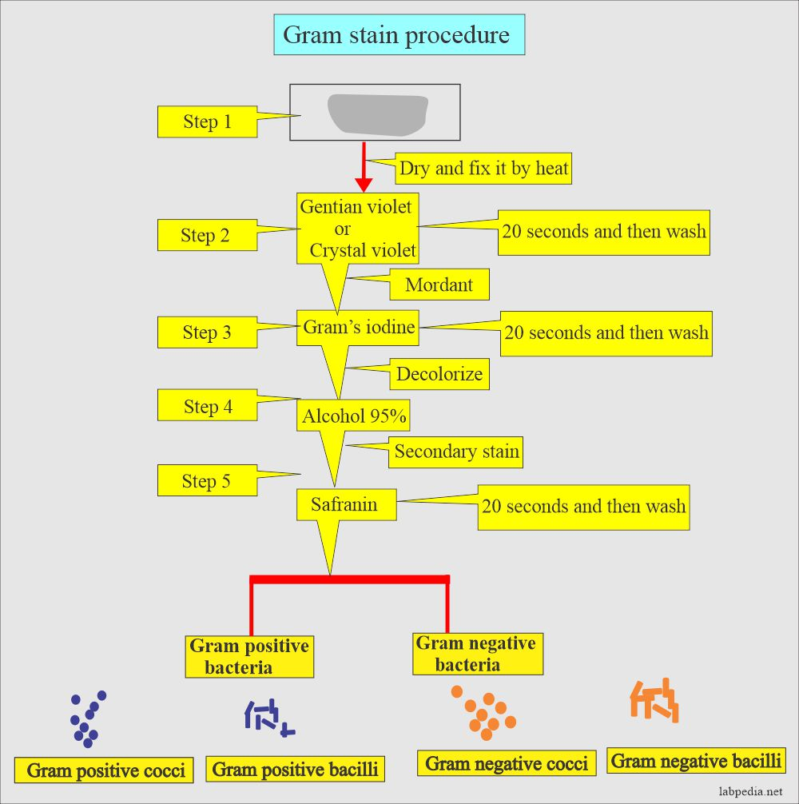
Life style of bacteria :
- Aerobic bacteria:
- Those bacteria which require oxygen for the complete oxidation of food into CO₂ and water.
- Example- Azotobacter, Mycobacterium.
- Anaerobic bacteria:
- These bacteria can not grow in presence of oxygen. They survive only in anaerobic condition.
- Example- Clostridium botulinum.
- Facultative bacteria:
- These bacteria can live in presence of oxygen as well as in the absence of oxygen.
- These are generally anaerobic but respires aerobically in presence of oxygen.
- Example- photosynthetic bacteria.

NUTRITION IN BACTERIA:
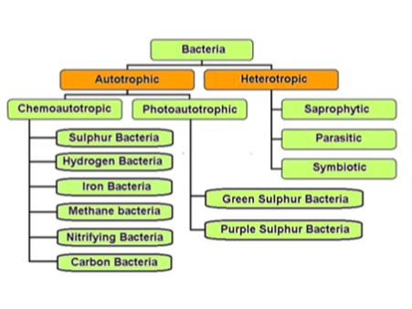
- Autotrophic: These bacteria are able to synthesize their own food. They may be photoautotroph or chemoautotroph.
- Photoautotrphs:
- These bacteria uses sunlight as a source of energy. They have pigments to absorb sunlight.
- Main pigments are- bacterial chlorophyll and bacterio viridin.
- They do not split water to obtain reducing power. So, oxygen is not evolved as a byproduct.
- Here, the hydrogen is obtained from other substances like H₂S.
- Example- green sulphur bacteria (Chlorobium), non sulphur bacteria (Rhodospirillum)etc.
- In green sulphur bacteria: here sulphur is produced as a byproduct.
6CO₂ + 12 H₂S ---------- C₆H₁₂O₆ + 12S + 6 H₂O
- In non-sulphur bacteria, other organic compounds are used as hydrogen donar in place of H₂S. So, sulphur is not produced as a byproduct.
- Chemoautotrophs:
- They are non-photosynthetic autotrophs or chemosynthetic bacteria.
- They lacks chorophyll hence, can not use sunlight.
- They uses different chemicals to get energy.
- Example- sulphur bacteria, hydrogen bacteria, iron bacteria, nitrifying bacteria, carbon bacteria.
- Hydrogen bacteria oxidize molecular hydrogen to water with the release of energy.
H₂ + ½ O₂ --------- H₂O + energy
- Sulphur bacteria like Thiobacillus oxidizes hydrogen sulphide or molecular sulphide to molecular sulphur. Energy thus released is used by bacteria for food synthesis.
2H₂S + O₂ ------- 2S+ 2H₂O+ energy
- Nitrifying bacteria uses ammonia and changes them into nitrite and nitrate. Example- Nitrosomonas, Nitrococcus, Nitrobacter.
NH₃ +O₂ –_^{Nitrosomonas} /^{Nitrococcus} NO₂⁻ (nitrite) +energy
NO₂⁻ + O₂ -^{Nitrobacter}----- NO₃⁻ (nitrate) + energy
- Heterotrophs:
- These bacteria do not prepare their own food.
- They obtain ready-made food from external sources or other organisms.
- These are of three types-
- Saprophytic bacteria:
- These are free living bacteria and grow on dead and decaying organic matter.
- They live by digesting and absorbing these organic matters.
- Saprophytic bacteria secrete different digestive enzymes and decompose complex organic compounds into simpler products.
- If breakdown of carbohydrates is done by bacteria, it is called as fermentation.
- If breakdown of protein takes place, it is called as putrefaction.
- These bacteria are the major decomposers of nature and are essential for recycling of nutrients. Example- Pseudomonas.
- Symbiotic bacteria:
- Some bacteria live in close relationship with other living organism.
- In this relationship both the partners are mutually benefited. Such relationship is called as symbiosis.
- Example- Rhizobium or nitrogen fixing bacteria lives in the root nodules of leguminous plants and fixes nitrogen. It provides nitrogen to the plants and in return gets shelter and carbohydrates from the plants.
- Parasitic bacteria:
- These live on or within the living plants or animals.
- They obtain food from the host on which they grow.
- Most of the parasites are harmful and causes disease in the host.
- Example- Clostridium botulinum causes food poisoning.
Clostridium tetani cause tetanus.

Reproduction in Bacteria:
Bacteria show both asexual and sexual reproduction.
- Asexual reproduction: It involves one cell and no gamete formation and exchange of genetic material is seen. It is of following types:
- Binary fission:
- It takes place in favourable condition.
- If all the conditions are optimum then E. coli would divide every 20 minutes in two daughter cells.
- Here at first bacterial DNA divides into two parts and then a partition in cytoplasm arises which give rise to two daughter cells.

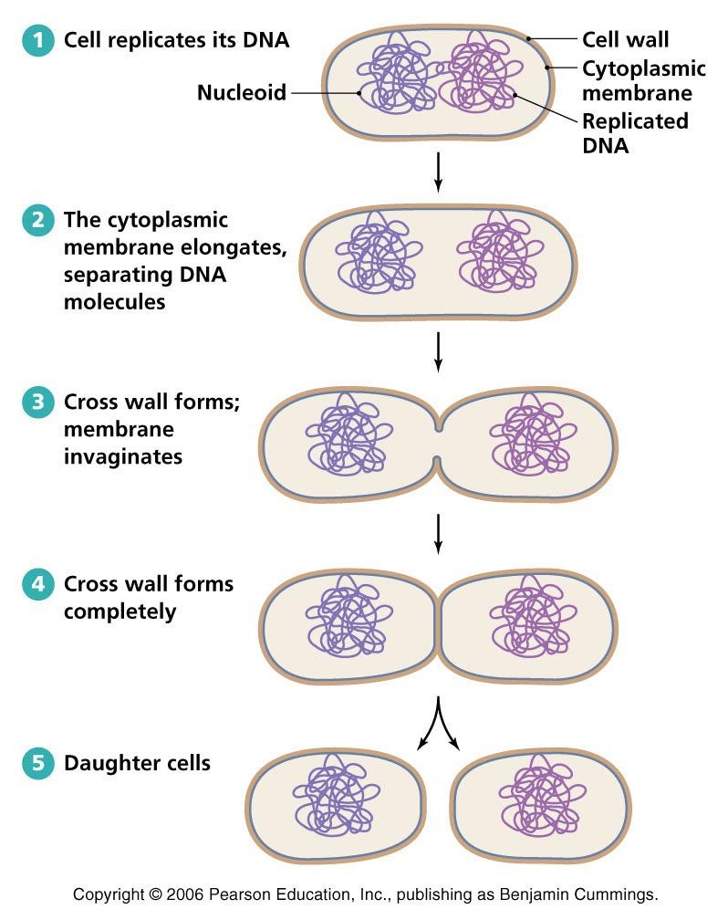
- Endospore formation:
- In unfavourable conditions bacterial cell loses its water and secrete a thick cortex around it. It is called endospore.
- Endospore is actually a structure which help in surviving during unfavourable condition not in reproduction.

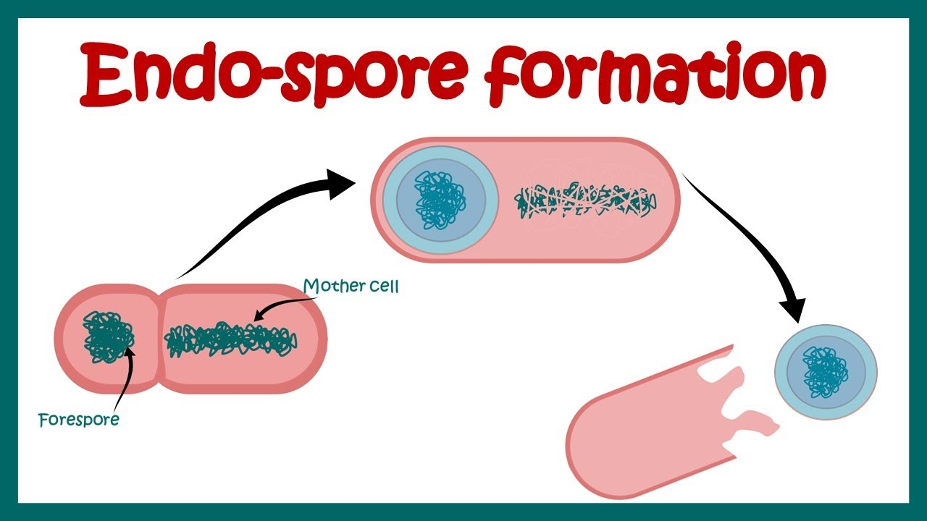

- Budding: It is very- very rare in Bacteria but has been recorded.

- Sexual reproduction:
- There is exchange of genetic material so we call it sexual reproduction. There are three methods of sexual reproduction in bacteria- transformation, transduction and conjugation.
- Tranformation:
- It was proposed by Griffith.
- The genetic material of one bacterium transforms the genetic material of other bacterium.
- Transduction:
- It was given by Zinder and Laderberg.
- Transfer of genetic material of one bacteria into other bacteria via Bacteriophage (a virus).
- Conjugation:
- It was given by Laderberg and Tatum.
- In some bacteria, fertility gene or F-gene is present in their plasmid. Such bacteria are called F+ bacteria or donor cell or male cell.
- The bacteria which do not have F-gene are called F- bacteria or recipient cell or female cell.
- During conjugation two cells come in contact of each other with the help of pilli. Now, this pilli forms a conjugation tube.
- At the same time F+ cell divides its plasmid and this plasmid is transferred to F- cell through the conjugation tube.
- Now, both the cells become F+ cells.
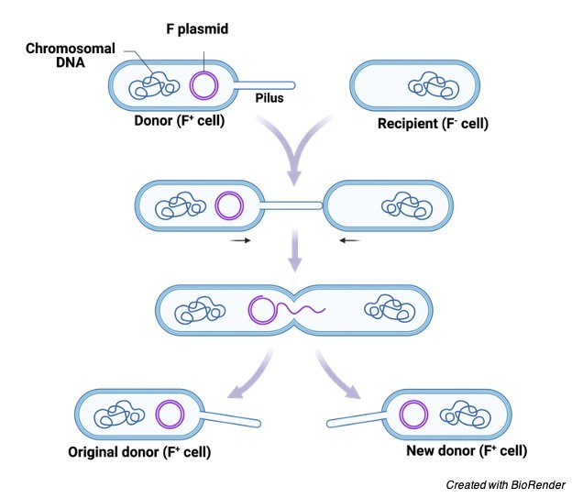

ECONOMIC IMPORTANCE OF BACTERIA:
Useful aspects of bacteria:
- Bacteria as decomposers:They have enormous power of decomposition of plant and animal debris into their constituent elements like C, H, O, N, S and P and make them available for plants as a raw material. In this way they keep earth surface clean. Example- Bacillus subtilis.
- Role in soil fertility: Saprophytic and symbiotic bacteria plays a vital role in agriculture by adding nitrates and ammonia to the soil and increases the fertility of the soil.
- Nitrification: The ammonia present in dead organism is used by nitrifying bacteria and converted into nitrate which are used by green plants. Example- Nitrococcus, Nitrosomonas.
- Nitrogen fixation: Many bacteria can fix atmospheric nitrogen. Free living bacteria Azotobacter lives in soil and fixes nitrogen whereas symbiotic bacteria Rhizobium lives in the root nodules of leguminous plants and fixes nitrogen.
- Role of bacteria in Industries:
- Dairies: Bacteria are useful in dairy industry. Lacto bacilli helps in formation of curd and cheese. It also helps in producing flavour in butter.
- Vinegar industry: Vinegar is obtained by fermentation of sugary solution with the help of Acetobacter aceti.
- Tea and tobacco: The curing and ripening of tea and tobacco leaves are brought about by Micrococcus bacteria. This is useful in the preparation and flavouring of tea.
- Fibre retting: The process of separating fibres from plant is called as retting. Bacteria are used in this process. Bacteria causes decy of softer tissue and make it easier to separate fibre mechanically. Fibres of flax, jute, coconut etc. can be obtained by immersing the plants in stagnant water where bacteria develop and cause retting.
- Leather industry: Certain bacteria are used in the tanning of hides. Bacteria decomposes fat and skin tissue and ultimately leather is formed.
- Role in antibiotic production: Antibiotics are the substances produced synthetically by micro organisms which checks production of pathogen.
First antibiotic is Penicillin which was discovered by Alexander Flamming. Many antibiotics are produced by bacterium Streptomyces.

Antibiotic Bacteria
Terramycin Streptomyces rimosus
Erythromycin Streptomyces erythreus
Kanamycin S. kanamycenticus
Neomycin S. fradiae
Gentamycin Micromonospora
Penicillin G Penicillium chrysogenum
- Vaccine production: Vaccines are preparation of killed or living micro-organism which produce immunity when introduced inro a body.
Vaccine curable disease
BCG (living vaccine) tuberculosis
Typhoid vaccine (killed) typhoid
Cholera vaccine (killed) cholera
Oral polio vaccine (living) polio
Mumps vaccine (living) mumps,measels rubella
- Vitamin production: Many bacteria are used in the production of different vitammins. Example- Clostridium butylicum- vit. Riboflavin
- Enzyme production: Different enzymes are also produced with the help of bacteria. Enzyme amylase and protease are manufactured from Bacillus subtilis.
- Sewage disposal: Sewage contains different types of waste materials like industrial waste, human waste, animal waste etc. Before disposing the sewage into river it must be treated. Bacteria break these organic compounds anaerobically into methane and carbondioxide. This makes sewage water less harmful and methane thus produced is used as fuel.
- Harmful aspects:
- Diseases: Bacteria causes so many disease in humans, animals and plants.
Bacteria disease
Diplococcus pneumoniae ----- pneumonia
Streptococcus phyegens --------sore throat
Vibrio cholerae--------------------cholera
Mycobacterium tuberculosis---tuberculosis
Corynebacterium diptheriae---diptheria
Bacillus anthracis-----------------anthrax
Xanthomonas citri--------------- citrus cancer (in citrus plants)
Corynebacterium sepedonium--- ring rot disease of potato
- Food spoilage (food poisoning): Some saprophytic bacteria spoil the food stuffs by causing decay. Clostridium botulinum produces a very virulent poison in canned foods which is fatal.
- Denitrification: Some bacteria like Thiobacillus, Micrococcus, Bacillus denitrificans etc. reduce the nitrate into free nitrogen. By this activity the fertility of soil decreases.
- Cotton deterioration: Many bacteria of genera Vibrio and Cellulomonas destroys cotton and articles made from it.
- Water pollution: Many bacteria which are pathogenic in nature can multiply at faster rate in stagnant water. so, bacterial contamination in water degrades water quality for drinking.
Example- Vibrio cholerae, Salmonella typhi etc.

